WEEK 03 TASK
Statistical Analysis and Predictive Modeling using R

PROJECT TITLE
ADVERTISING SALES PREDICTIONS

Dataset: Advertising Dataset
Analysis Tool: R Programming / RStudio
Project Type: Statistical Analysis & Predictive Modeling
Submitted by: RAJESH M

TABLE OF CONTENT
1. Introduction.
2. Project Background.
3. Problem Statement.
4. Objectives of the Project.
5. Dataset Description.
6. Tools and Technologies Used.
7. Data Preparation.
8. Exploratory Data Analysis.
9. Statistical Testing.
10. Regression Model Development.
11. Train-Test Split.
12. Model Evaluation.
13. Model Diagnostics.
14. Model Improvement.
15. Cross-Validation.
16. Results and Findings.
17. Business Insights.
18. Limitations.
19. Recommendations.
20. Conclusion.
21. GitHub Repository.
22. Appendix – R Program Code.
23. References.
1. INTRODUCTION
In the present business environment, organizations generate and collect large amounts of data through their daily operations, marketing activities, customer interactions and sales transactions. The effective analysis of this data has become an important part of business decision-making. Instead of relying only on assumptions or traditional methods, organizations can use statistical techniques and predictive models to identify patterns, understand relationships and support better managerial decisions. Among various business functions, advertising and sales analysis is particularly important because organizations invest significant amounts of money in different advertising channels with the expectation of generating higher sales. Advertising plays an important role in creating awareness about products and services and influencing customer purchasing decisions. However, the effectiveness of different advertising channels may not be the same. Television, radio and newspaper advertising may contribute differently to sales depending on the target audience, market conditions and advertising strategy. Therefore, analyzing historical advertising expenditure and sales data can help an organization understand which channels have a stronger relationship with sales and which channels provide relatively less predictive value.
The present project focuses on the statistical analysis and predictive modeling of advertising expenditure and sales using the Advertising dataset. The dataset contains information related to expenditure on three advertising channels, namely TV, radio and newspaper, along with the corresponding sales values. In this analysis, sales is considered the dependent variable, while TV, radio and newspaper advertising expenditure are considered independent variables. The main purpose of the project is to examine the relationships between these variables and develop a suitable statistical model for predicting sales. R programming and RStudio were used as the primary analytical tools throughout the project. R provides a wide range of functions for data manipulation, statistical testing, visualization and predictive modeling. The project begins with data inspection and exploratory analysis to understand the structure and characteristics of the dataset. Correlation analysis is then performed to identify the strength and direction of relationships between advertising expenditure and sales. Following the exploratory analysis, hypothesis testing is performed to determine whether the observed relationships are statistically significant. A Shapiro-Wilk test is also conducted to examine the normality of the sales variable. Multiple linear regression is then applied to understand the combined effect of TV, radio and newspaper advertising expenditure on sales. The regression model is evaluated using statistical significance, R-squared and other performance measures. To assess the predictive capability of the model, the dataset is divided into training and testing sets. The model is trained using 80% of the observations and evaluated using the remaining 20%. Performance metrics such as Root Mean Square Error (RMSE), R-squared and Mean Absolute Error (MAE) are used to measure prediction accuracy. Model diagnostic plots, including Residuals vs Fitted and Q-Q Residuals plots, are also examined to identify potential issues in the regression assumptions.
Finally, an improved model is developed by removing the predictor that does not provide significant additional explanatory information. The performance of the improved model is compared with the initial model, followed by 10-fold cross-validation to assess the stability of the predictions. Through this complete analytical process, the project demonstrates how statistical analysis and predictive modeling can be applied to a practical business problem and how the results can support data-driven advertising and sales decisions.

2. PROJECT BACKGROUND
In today’s competitive business environment, advertising has become an important component of marketing strategy. Organizations invest in different advertising channels to communicate information about their products and services to potential customers. The major objective of advertising is to increase product awareness, attract new customers, influence purchasing decisions and ultimately improve sales performance. However, the amount spent on advertising does not always produce the same level of results across different channels. Therefore, understanding the relationship between advertising expenditure and sales is important for organizations when planning their marketing budgets. The background of this project is based on the practical need to understand how different advertising channels are associated with sales performance. In the selected dataset, advertising expenditure is divided into three major channels: Television (TV), Radio and Newspaper. Each observation represents advertising expenditure across these channels along with the corresponding sales value. By analyzing these observations, statistical techniques can be used to identify patterns and determine whether higher expenditure in a particular advertising channel is associated with higher sales.
Television advertising represents one of the major traditional advertising channels and generally has the ability to reach a large audience. In the dataset, TV expenditure shows a relatively strong relationship with sales. This makes TV an important variable for further statistical analysis and predictive modeling. Radio advertising represents another traditional marketing channel that can reach specific audiences through audio-based communication. The relationship between radio expenditure and sales is also positive, although it is comparatively weaker than the relationship observed for TV advertising. Newspaper advertising represents a print-based advertising channel. Compared with TV and radio, the relationship between newspaper expenditure and sales is relatively weak in the dataset. This does not necessarily mean that newspaper advertising has no business value. Instead, it indicates that newspaper expenditure provides comparatively less information for predicting sales when compared with the other available advertising variables. Statistical analysis is therefore required before making decisions regarding the importance of each advertising channel.
The project also provides an opportunity to understand how statistical techniques can be applied to a real-world business problem. Simple observation of the data may show that advertising expenditure and sales move together, but statistical analysis is required to measure the strength of these relationships objectively. Correlation analysis is therefore used to determine the direction and strength of relationships between individual advertising variables and sales. Hypothesis testing is then applied to determine whether these observed relationships are statistically significant. Another important aspect of the project is predictive modeling. Organizations are not only interested in understanding historical relationships but also in estimating potential future outcomes. Multiple linear regression provides a suitable approach for this purpose because it allows sales to be predicted using multiple advertising expenditure variables simultaneously. The model also provides coefficient estimates that help explain how changes in individual predictors are associated with changes in the predicted sales value while keeping other predictors constant. The project uses R and RStudio to perform the complete analytical process. R is particularly suitable for this project because it provides built-in statistical functions and packages for data analysis, visualization and regression modeling. RStudio provides an organized environment where the dataset, R scripts, statistical outputs and visualizations can be managed efficiently. Using R also makes the analysis reproducible because the same commands can be executed again on the same dataset to obtain the same results. The project further incorporates model evaluation and validation techniques. Instead of evaluating the regression model only on the observations used for training, an 80:20 train-test split is used. The training data is used to develop the model, while the testing data is used to evaluate its predictive performance. Metrics such as RMSE, R-squared and MAE are used to understand the accuracy of the predictions. Model diagnostic plots are also analyzed to identify unusual observations and possible deviations from regression assumptions.
Overall, the background of this project combines marketing analysis, statistical analysis and predictive modeling. The Advertising dataset provides a practical example through which the relationship between advertising expenditure and sales can be studied systematically. The project demonstrates how raw business data can be transformed into meaningful statistical information and how the resulting insights can support more informed marketing and sales decisions.

3. PROBLEM STATEMENT
In a competitive business environment, organizations invest considerable amounts of money in advertising to promote their products and increase sales. However, different advertising channels may not contribute equally to sales performance. Therefore, organizations need to understand which advertising channels have a stronger relationship with sales and which channels provide comparatively less value. The main problem addressed in this project is to analyze the relationship between TV, radio and newspaper advertising expenditure and sales. Simply observing the data may show that advertising expenditure and sales move together, but statistical analysis is required to determine the strength and significance of these relationships.
Another important problem is identifying the most useful variables for building a sales prediction model. Including unnecessary variables can make a model more complicated without improving its accuracy. Therefore, correlation analysis, hypothesis testing and multiple linear regression are used to evaluate the contribution of each advertising variable. The project also focuses on determining how accurately sales can be predicted using advertising expenditure. For this purpose, the dataset is divided into training and testing data. The developed model is evaluated using RMSE, R-squared and MAE. Model diagnostic plots and cross-validation are also used to understand the reliability and stability of the model.
Therefore, the central problem of this project is to determine which advertising channels have the strongest relationship with sales and whether these variables can be used to develop an accurate and reliable sales prediction model using R.

4. OBJECTIVES OF THE PROJECT
The main objective of this project is to analyze the relationship between advertising expenditure and sales using statistical techniques in R. The project aims to convert the available advertising data into meaningful insights that can support better understanding of sales performance and help in developing an effective prediction model.
The specific objectives of the project are:
- To understand the Advertising dataset and examine the variables, observations and overall structure of the data.
- To analyze the relationship between TV, radio, newspaper and sales using descriptive statistics and correlation analysis.
- To perform hypothesis testing to determine whether the observed relationships between advertising expenditure and sales are statistically significant.
- To develop a multiple linear regression model using advertising expenditure as independent variables and sales as the dependent variable.
- To evaluate the predictive performance of the regression model using RMSE, R-squared and MAE.
- To identify statistically significant predictors and determine whether any variables can be removed without reducing model performance.
- To perform model diagnostics using Residuals vs Fitted and Q-Q Residuals plots to identify possible patterns and unusual observations.
- To develop an improved predictive model by selecting the most useful advertising variables.
- To perform 10-fold cross-validation to evaluate the stability and reliability of the improved model.
- To interpret the statistical results from a business perspective and provide suitable recommendations based on the findings.
Overall, these objectives help the project demonstrate how R-based statistical analysis and predictive modeling can be applied to a practical advertising and sales problem.

5. DATASET DESCRIPTION
The Advertising dataset is used for this project to analyze the relationship between advertising expenditure and sales. The dataset contains 200 observations and four main variables: TV, radio, newspaper and sales. The first three variables represent advertising expenditure through different media channels, while sales is considered the dependent or target variable. TV represents the amount spent on television advertising. It is one of the major advertising channels in the dataset and shows a strong positive relationship with sales. Radio represents expenditure on radio advertising and also shows a positive relationship with sales. Newspaper represents expenditure on newspaper advertising and has a comparatively weaker relationship with sales. The sales variable represents the outcome that the project aims to understand and predict. Since sales is influenced by several advertising variables, multiple linear regression is used to examine their combined relationship with the target variable. The dataset contains numerical values and does not have missing observations, making it suitable for statistical analysis and predictive modeling. Before developing the regression model, the data is explored using summary statistics, correlation analysis and visualizations. This helps in understanding the characteristics of each variable and identifying possible relationships. The dataset is particularly useful for this project because it provides a simple business scenario where marketing expenditure can be compared with sales performance. By analyzing the data systematically, the project can identify which advertising channels provide the strongest predictive information and develop a suitable model for estimating sales.

6. TOOLS AND TECHNOLOGIES USED
This project was completed using R programming and RStudio as the primary tools for statistical analysis and predictive modeling. R was selected because it provides a wide range of built-in functions for data analysis, statistical testing, visualization and regression modeling. It also allows the complete analysis process to be performed through reproducible code.
RStudio was used as the development environment for writing and executing R code. It provided separate sections for the script, console, environment and plots, making it easier to manage the project workflow. The R script was saved so that the analysis could be reproduced whenever required. The Advertising.csv file was used as the main dataset. R functions such as read.csv(), summary(), cor(), cor.test() and shapiro.test() were used for data exploration and statistical testing. The lm() function was used to develop the multiple linear regression model. For visualization, R plotting functions were used to create the scatterplot matrix, Residuals vs Fitted plot and Q-Q Residuals plot. These visualizations helped in understanding relationships between variables and checking model behavior. GitHub was also used to maintain and present the project files. The R script, dataset and generated output files can be stored in the repository, making the project easier to access, organize and demonstrate as part of the internship submission.
Overall, the combination of R, RStudio, the Advertising dataset and GitHub provided a complete environment for performing statistical analysis, predictive modeling, visualization and project documentation.

7. DATA PREPARATION
Before performing statistical analysis and predictive modeling, the Advertising dataset was prepared and checked to ensure that the data was suitable for further analysis. The dataset was imported into RStudio using the read.csv() function and its structure was examined to understand the number of observations, variables and their data types. The dataset contains 200 observations and four numerical variables: TV, radio, newspaper and sales. Since all variables are numerical, they can be directly used for correlation analysis and linear regression without requiring categorical encoding. A summary of the dataset was also generated to understand the minimum, maximum, mean, median and quartile values of each variable. This helped identify the overall distribution and range of the data. A missing-value check was performed to ensure that incomplete observations would not affect the statistical analysis. The data was also checked for obvious inconsistencies before proceeding with visualization and modeling. Since the dataset was already structured in a suitable numerical format, no major data transformation was required. The original observations were retained to preserve the information available in the dataset. After completing these checks, the dataset was considered suitable for exploratory analysis, hypothesis testing and regression modeling. The prepared dataset was then used for correlation analysis and visualization to understand the relationship between advertising expenditure and sales.
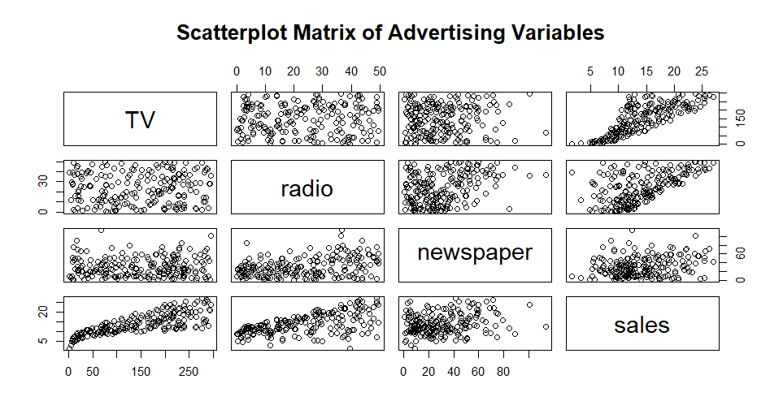
8. EXPLORATORY DATA ANALYSIS

Figure 1: Scatterplot Matrix of Advertising Variables
Exploratory Data Analysis (EDA) was performed to understand the basic characteristics and relationships present in the Advertising dataset before developing the predictive model. This stage helps identify important patterns in the data and provides an initial understanding of how the advertising variables are related to sales.
The analysis focused mainly on TV, radio, newspaper and sales. Summary statistics were examined to understand the range and distribution of the variables. Correlation analysis was then used to measure the strength and direction of the relationship between each advertising channel and sales. A scatterplot matrix was also created in R to visually examine the relationships between the variables. The visualization clearly indicated that TV advertising has a stronger positive relationship with sales compared with newspaper advertising. Radio also showed a positive relationship with sales, although the relationship was comparatively moderate.
The correlation results provided further support for these observations. TV and sales had a correlation coefficient of 0.7822, indicating a strong positive relationship. Radio and sales had a correlation of 0.5762, indicating a moderate positive relationship. Newspaper and sales had a correlation of 0.2283, indicating a weak positive relationship.
EDA was important because it provided the foundation for the statistical testing and regression modeling stages. The findings suggested that TV and radio could be important predictors of sales, while newspaper might provide comparatively less predictive information. However, statistical testing and regression analysis were required to confirm these observations.

9. STATISTICAL TESTING
Statistical testing was performed to determine whether the relationships identified during exploratory analysis were statistically significant. The main purpose of this stage was to verify whether the observed relationships between advertising expenditure and sales could be considered meaningful rather than occurring only due to random variation. Pearson correlation hypothesis tests were conducted separately for TV, radio and newspaper advertising against sales. The TV-sales relationship produced a correlation coefficient of 0.7822 with a p-value below 2.2e-16, indicating a highly significant positive relationship. Similarly, radio and sales produced a correlation of 0.5762 with a p-value below 2.2e-16, confirming a statistically significant positive relationship. The newspaper-sales relationship produced a correlation coefficient of 0.2283 with a p-value of 0.001148. Although this represents a weak relationship, the p-value is below the 5% significance level, so the standalone relationship is statistically significant. A Shapiro-Wilk normality test was also performed for the sales variable. The test produced a W value of 0.97603 and a p-value of 0.001683. Since the p-value is below 0.05, the null hypothesis of normality was rejected, indicating that the sales variable does not perfectly follow a normal distribution. Overall, the statistical testing results provide evidence that TV and radio have particularly meaningful relationships with sales. These findings were subsequently considered during the regression modeling stage to determine the combined predictive contribution of the advertising variables.
10. REGRESSION MODEL DEVELOPMENT
Multiple Linear Regression was used to examine the combined relationship between advertising expenditure and sales. In this model, sales was considered the dependent variable, while TV, radio and newspaper advertising expenditure were initially considered independent variables.
The initial regression model was developed using the lm() function in R. The model produced the following equation:
Sales = 2.9389 + 0.0458(TV) + 0.1885(Radio) − 0.0010(Newspaper)
The model achieved a Multiple R-squared value of 0.8972 and an Adjusted R-squared value of 0.8956. This indicates that approximately 89.72% of the variation in sales can be explained by the three advertising variables included in the model.
The regression results showed that TV and radio were statistically significant predictors of sales, with very small p-values. On the other hand, newspaper advertising produced a p-value of approximately 0.86, indicating that it was not statistically significant when TV and radio were included in the same model.
The overall regression model was statistically significant, with an F-statistic of approximately 570.3 and a p-value below 2.2e-16. This indicates that the predictors, when considered together, provide significant explanatory information about sales.
The regression model therefore provided a strong initial foundation for sales prediction. However, since newspaper did not provide significant additional information, an improved model using only TV and radio was later developed and compared with the initial model.

11. TRAIN-TEST SPLIT
To evaluate the predictive performance of the regression model, the Advertising dataset was divided into two separate groups: training data and testing data. An 80:20 ratio was used for the split, resulting in 160 observations for training and 40 observations for testing.
The training dataset was used to develop the regression model and estimate the relationship between advertising expenditure and sales. The testing dataset was kept separate from the model development process and was used only to evaluate how accurately the model could predict sales for unseen observations.
A random seed of 123 was used before creating the split. Using a fixed seed makes the analysis reproducible because the same observations will be selected whenever the code is executed again. This is particularly useful when sharing the R project through GitHub or reviewing the analysis at a later stage.
After the split, the initial regression model containing TV, radio and newspaper was fitted using the training data. Predictions were then generated for the 40 observations in the testing dataset. These predicted values were compared with the actual sales values to calculate the model performance measures.
The train-test approach provides a more realistic assessment of predictive performance than evaluating the model only on the data used for training. It helps determine whether the relationships identified by the model can be applied to new observations. The results from this evaluation were later used to compare the initial model with the improved TV and radio model.

12. MODEL EVALUATION
The developed regression model was evaluated using three important performance metrics: Root Mean Square Error (RMSE), R-squared and Mean Absolute Error (MAE). These metrics help to understand how accurately the model predicts sales values for the testing dataset.
The initial model achieved a test RMSE of 1.43808. RMSE measures the average magnitude of prediction errors and gives greater importance to larger errors. Therefore, a lower RMSE indicates better predictive performance.
The model achieved a test R-squared value of 0.924969. This indicates that approximately 92.50% of the variation in the testing-set sales values was explained by the model. A higher R-squared generally indicates that the model has stronger explanatory and predictive capability.
The Mean Absolute Error (MAE) was 1.212977. This represents the average absolute difference between the actual sales values and the predicted sales values. In simple terms, the model's predictions differed from the actual sales values by approximately 1.21 units on average.
These results indicate that the initial regression model performed well on the unseen testing data. However, model evaluation was not limited to these metrics. The model was also examined using diagnostic plots, and an improved model was later developed by removing the statistically insignificant newspaper variable. This allowed the performance of both models to be compared and helped identify the more efficient predictive model.

13. MODEL DIAGNOSTICS
Model diagnostics were performed to examine whether the regression model provides a reasonable fit to the data and to identify any unusual patterns in the residuals. Two important diagnostic plots were used: the Residuals vs Fitted plot and the Q-Q Residuals plot.
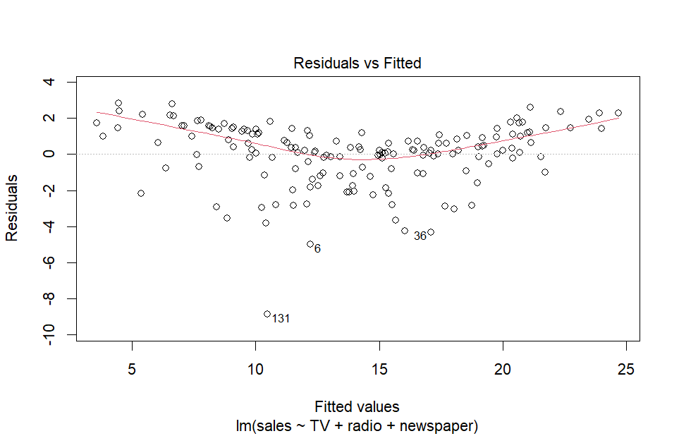

Figure: 02 Residuals vs Fitted Plot
The Residuals vs Fitted plot is used to examine whether the residuals are randomly distributed around zero. In the analysis, most residuals are distributed around the zero line, but some curvature and relatively large residuals can be observed. This suggests that a small amount of systematic variation may remain unexplained by the linear regression model.

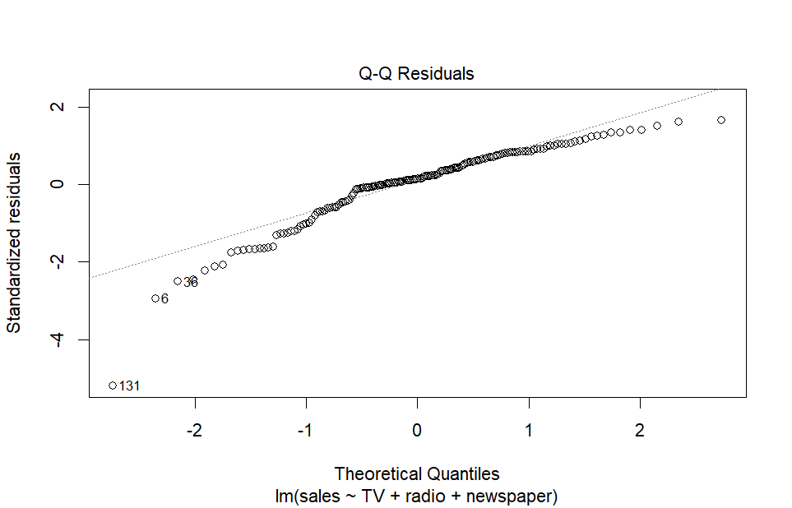
Figure: 03: Q-Q Residuals plot
The Q-Q Residuals plot was used to examine the distribution of the regression residuals. Most observations are reasonably close to the reference line in the central region, while some deviations can be observed toward the tails. This indicates that the residuals do not follow a perfectly normal distribution and that a few observations may behave differently from the majority.
These diagnostic results do not necessarily mean that the regression model is unsuitable. Instead, they highlight areas that may require further investigation. In particular, observations with large residuals can be examined to determine whether they represent unusual business situations or influential observations.
Overall, the diagnostic analysis provides additional information beyond numerical performance metrics. While the model demonstrates strong predictive performance, the residual plots indicate that some minor patterns and deviations remain. These findings were considered while developing and evaluating the improved model.
14. MODEL IMPROVEMENT
Based on the initial regression analysis, newspaper advertising was found to be statistically insignificant when TV and radio were considered together. Therefore, an improved regression model was developed by removing the newspaper variable and using only TV and radio as predictors.
The improved model can be represented as:
Sales = 2.9265 + 0.0460(TV) + 0.1850(Radio)
The performance of the improved model was compared with the initial model using the same testing dataset. The improved model achieved a RMSE of 1.405747, which was lower than the initial model's RMSE of 1.43808. The model also achieved a R-squared value of 0.9280601, compared with 0.924969 for the initial model.
The MAE decreased from 1.212977 to 1.177188, indicating that the average prediction error also improved. These results show that removing the newspaper variable did not reduce the predictive capability of the model. Instead, the simpler model produced slightly better results across all three evaluation measures.
The improved model is also easier to interpret because it contains only two important predictors. This demonstrates that a model with fewer variables can sometimes provide better performance when unnecessary or statistically insignificant predictors are removed.
Overall, the improved TV and radio model was selected as the preferred model because it provides better predictive performance while maintaining a simpler structure.

15. CROSS-VALIDATION
Cross-validation was performed to evaluate the stability and reliability of the improved regression model. In this project, 10-fold cross-validation was used, where the available data was divided into ten different subsets. During each iteration, nine subsets were used for training the model and the remaining subset was used for validation.
This process was repeated ten times so that each subset could be used as a validation set once. The prediction error from each fold was recorded and compared to understand how the model performs across different portions of the dataset. This provides a broader evaluation of the model than relying only on a single train-test split.
The mean cross-validation RMSE was 1.65365. The RMSE values varied between the individual folds, showing that prediction performance was not exactly the same for every subset of observations. Such variation is expected because different observations may contain different advertising and sales patterns.
Cross-validation is particularly useful because it helps determine whether the model's performance is reasonably consistent across different samples of the available data. A model that performs well only on one particular train-test split may not generalize effectively to new data. Therefore, cross-validation provides additional confidence when evaluating the predictive capability of the improved model.
The results from 10-fold cross-validation, together with the test-set RMSE, R-squared and MAE, provide a more complete view of the model's performance. Overall, the improved model demonstrated useful predictive capability, although the variation in cross-validation error indicates that model performance can change depending on the observations used for validation.
16. RESULTS AND FINDINGS
The statistical analysis and predictive modeling performed in this project produced several important findings regarding the relationship between advertising expenditure and sales. The exploratory analysis showed that TV advertising has the strongest positive relationship with sales, with a Pearson correlation coefficient of 0.7822. Radio advertising also showed a meaningful positive relationship with sales, with a correlation coefficient of 0.5762. Newspaper advertising showed a comparatively weak relationship, with a correlation coefficient of 0.2283.
The hypothesis testing results further supported the relationships identified during exploratory analysis. TV and radio produced highly significant p-values, indicating strong statistical evidence of their relationship with sales. Although newspaper was statistically significant when considered individually, it became insignificant in the multiple regression model after TV and radio were included.
The initial regression model containing all three advertising variables achieved an R-squared value of 0.8972, demonstrating strong explanatory capability. On the testing dataset, the model achieved an RMSE of 1.43808, R-squared of 0.924969 and MAE of 1.212977.
The improved model, which included only TV and radio, performed slightly better. It achieved an RMSE of 1.405747, R-squared of 0.9280601 and MAE of 1.177188. Therefore, removing the statistically insignificant newspaper variable improved the model while also making it simpler.
The 10-fold cross-validation produced a mean RMSE of 1.65365, providing additional information about the model's performance across different subsets of the dataset. Overall, the results indicate that TV and radio are the most useful predictors for sales in this dataset, and the improved two-variable model provides a strong and relatively simple approach for sales prediction.
17. BUSINESS INSIGHTS
The analysis provides several useful business insights regarding the relationship between advertising expenditure and sales. Among the three advertising channels considered in the project, TV advertising shows the strongest relationship with sales. This indicates that TV expenditure has historically provided the highest level of predictive information about sales within the dataset.
Radio advertising also demonstrates a meaningful positive relationship with sales. Although its correlation is lower than TV, it contributes significantly to the regression model. Therefore, radio can be considered an important supporting advertising channel when developing a sales prediction strategy.
The analysis also provides an important insight regarding newspaper advertising. Newspaper has a weak positive standalone relationship with sales and becomes statistically insignificant when TV and radio are included in the regression model. This suggests that, based on this dataset, newspaper expenditure provides limited additional information for predicting sales.
From a business perspective, the results can help management focus more attention on advertising channels that demonstrate stronger relationships with sales. However, the findings should not be interpreted as proof that increasing TV or radio expenditure will automatically increase sales by a specific amount. Advertising decisions should also consider factors such as campaign quality, target customers, pricing, competition and market conditions.
Overall, the analysis demonstrates how statistical modeling can support data-driven marketing decisions. Instead of evaluating advertising channels only through assumptions, organizations can use historical data and predictive models to understand performance and make more informed decisions regarding future advertising investments.
18. LIMITATIONS
Although the project provides useful statistical and predictive insights, certain limitations should be considered when interpreting the results. The first limitation is that the dataset contains only three advertising variables: TV, radio and newspaper. Other important factors that can influence sales, such as product price, discounts, customer preferences, seasonal demand, competitor activities and economic conditions, are not included in the dataset.
Another limitation is that the analysis is based on historical data. The relationships identified in the dataset may change over time due to changes in customer behavior, advertising platforms and market conditions. Therefore, the model should not be assumed to produce the same level of accuracy when applied to completely different future situations.
The regression model also has some diagnostic limitations. The Residuals vs Fitted and Q-Q Residuals plots indicate some deviations and potential unusual observations. These patterns suggest that the simple linear regression model may not capture every aspect of the relationship between advertising expenditure and sales.
Finally, correlation and regression results should not be interpreted as direct proof of causation. A strong statistical relationship between advertising expenditure and sales does not necessarily mean that advertising expenditure alone caused the increase in sales. Other factors may also influence the observed results.
Despite these limitations, the project provides a useful demonstration of how statistical analysis and predictive modeling can be applied to advertising and sales data. Further improvements can be made by incorporating additional business variables and testing alternative modeling techniques.

19. RECOMMENDATIONS
Based on the statistical analysis and model evaluation, several recommendations can be made for improving advertising and sales decision-making. The results indicate that TV and radio advertising provide stronger predictive information about sales compared with newspaper advertising. Therefore, organizations can give greater analytical attention to these channels when planning future advertising strategies.
However, advertising budget allocation should not be based only on correlation or regression results. Management should also consider the cost of each advertising channel, return on investment, target audience and campaign effectiveness. A channel with a strong relationship with sales may not always provide the highest financial return.
The improved regression model using TV and radio can be used as a basic sales prediction tool. Before using the model for actual business decisions, it should be tested with newer data to confirm that its predictive performance remains reliable.
Future analysis should include additional variables such as product pricing, promotional activities, seasonal factors, customer segments and competitor activity. Including these variables may improve the model's ability to explain changes in sales.
It is also recommended to periodically retrain and validate the model when new sales and advertising data become available. Additional machine-learning techniques can be compared with linear regression to determine whether more advanced models provide better predictive accuracy. Overall, the organization should use the model as a decision-support tool rather than as the only basis for marketing decisions. Combining statistical insights with business knowledge can lead to more effective advertising planning and better sales forecasting.
20. CONCLUSION
The Week 3 project successfully analyzed the relationship between advertising expenditure and sales using R programming and statistical modeling techniques. The Advertising dataset containing TV, radio, newspaper and sales variables was examined through data preparation, exploratory analysis, correlation analysis, hypothesis testing and regression modeling.
The analysis identified TV advertising as the strongest predictor of sales, while radio also showed a significant positive relationship. Newspaper advertising showed a comparatively weak relationship and was found to be statistically insignificant in the multiple regression model. Based on these findings, an improved model using only TV and radio was developed.
The improved model achieved a test RMSE of 1.405747, R-squared of 0.9280601 and MAE of 1.177188, showing strong predictive performance. Ten-fold cross-validation produced a mean RMSE of 1.65365, providing additional information about the model's stability.
Overall, this project demonstrates how statistical analysis can transform raw business data into meaningful insights. The findings can support better understanding of advertising effectiveness and provide a basic framework for sales prediction. The project also provided practical experience in RStudio, regression analysis, model evaluation, visualization, diagnostics and cross-validation.

21. GITHUB REPOSITORY
The complete Week 3 project has been organized and maintained through GitHub as part of the project submission. GitHub provides a centralized platform for storing the R programming files, dataset, analysis outputs and other supporting project materials. Maintaining the project in a repository also makes it easier to track the work and demonstrate the completed project during the internship evaluation.
The GitHub repository contains the important files related to the Advertising Sales Prediction using R project. The R program file contains the code used for data preparation, exploratory analysis, statistical testing, regression modeling, model evaluation and cross-validation. The dataset used for the analysis is also maintained along with the project files.
Using GitHub also provides an additional level of organization and reproducibility. If the analysis needs to be reviewed or repeated in the future, the saved R code can be executed again using the required dataset. This ensures that the results are not dependent only on screenshots or manually recorded outputs.
The project repository represents the final technical work completed during Week 3 and supports the documentation presented in this report.
GitHub Repository: https://github.com/rajesh06-m/Week-3-Statistical-Analysis-R.git
Project Title: Advertising Sales Prediction Using R
Programming Language: R
Development Environment: RStudio
Dataset: Advertising Dataset
Project Type: Statistical Analysis and Predictive Modeling

22. APPENDIX – R PROGRAM CODE
# Import Dataset
Advertising <- read.csv("Advertising.csv")

# View Dataset Structure
str(Advertising)

# Summary Statistics
summary(Advertising)

# Check Missing Values
colSums(is.na(Advertising))

# Correlation Analysis
cor(Advertising)

# Scatterplot Matrix
pairs(Advertising,
main = "Scatterplot Matrix of Advertising Variables")

# Hypothesis Testing
cor.test(Advertising$TV, Advertising$sales)

cor.test(Advertising$radio, Advertising$sales)

cor.test(Advertising$newspaper, Advertising$sales)

# Normality Test
shapiro.test(Advertising$sales)

# Initial Regression Model
model <- lm(
sales ~ TV + radio + newspaper,
data = Advertising
)

summary(model)

# Train-Test Split
set.seed(123)

sample_index <- sample(
1:nrow(Advertising),
size = 0.8 * nrow(Advertising)
)

train_data <- Advertising[sample_index, ]

test_data <- Advertising[-sample_index, ]

# Train Initial Model
train_model <- lm(
sales ~ TV + radio + newspaper,
data = train_data
)

# Prediction
predictions <- predict(
train_model,
newdata = test_data
)

# RMSE
rmse <- sqrt(
mean((test_data$sales - predictions)^2)
)

# R-Squared
r2 <- cor(
test_data$sales,
predictions
)^2

# MAE
mae <- mean(
abs(test_data$sales - predictions)
)

# Improved Model
improved_model <- lm(
sales ~ TV + radio,
data = train_data
)

# Improved Predictions
improved_predictions <- predict(
improved_model,
newdata = test_data
)

# Improved RMSE
improved_rmse <- sqrt(
mean((test_data$sales -
improved_predictions)^2)
)

# Improved R-Squared
improved_r2 <- cor(
test_data$sales,
improved_predictions
)^2

# Improved MAE
improved_mae <- mean(
abs(test_data$sales -
improved_predictions)
)

# Model Diagnostics
plot(improved_model, which = 1)

plot(improved_model, which = 2)

23. REFERENCES
The following resources were referred to during the development of the Week 3 statistical analysis and predictive modeling project. These references supported the understanding of R programming, statistical testing, regression analysis, model evaluation and data visualization.
- R Documentation – Statistical Functions and Linear Regression
- RStudio Documentation – R Development Environment
- ISLR – An Introduction to Statistical Learning
- Pearson – Statistical Methods and Regression Analysis
- Advertising Dataset – Dataset used for statistical analysis
- GitHub – Project repository and version management

